**Day 15 Assignment**

**Creating EC2 instance using terraform**

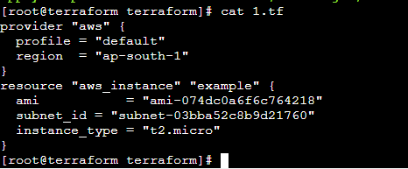

**Terraform Init**

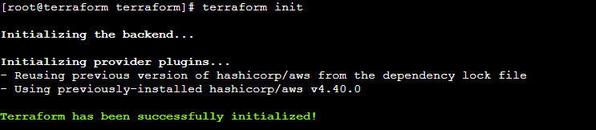

**Terraform validate**

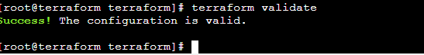

**Terraform apply**

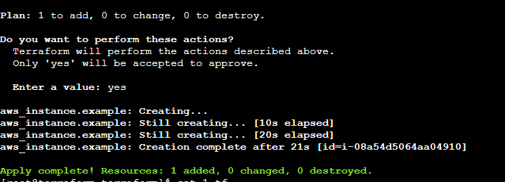

**Instance created**

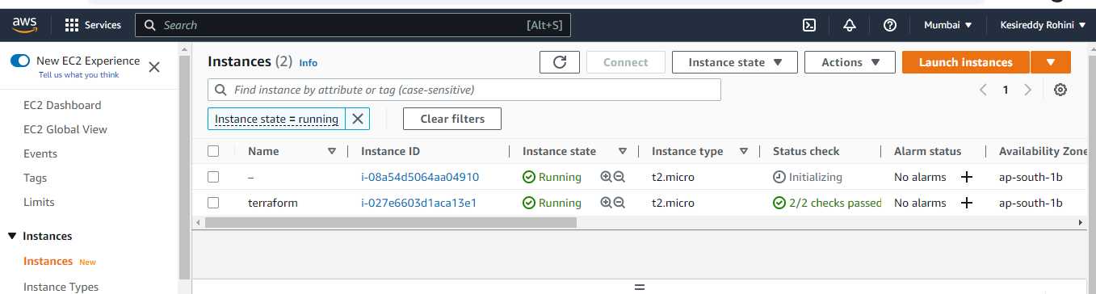

**Deleting thee instance which we have created**

**Terraform Destory**

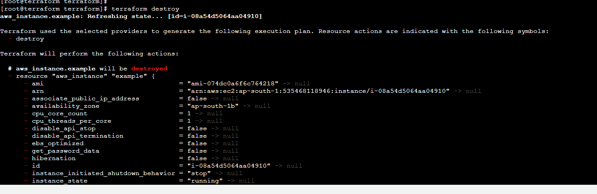

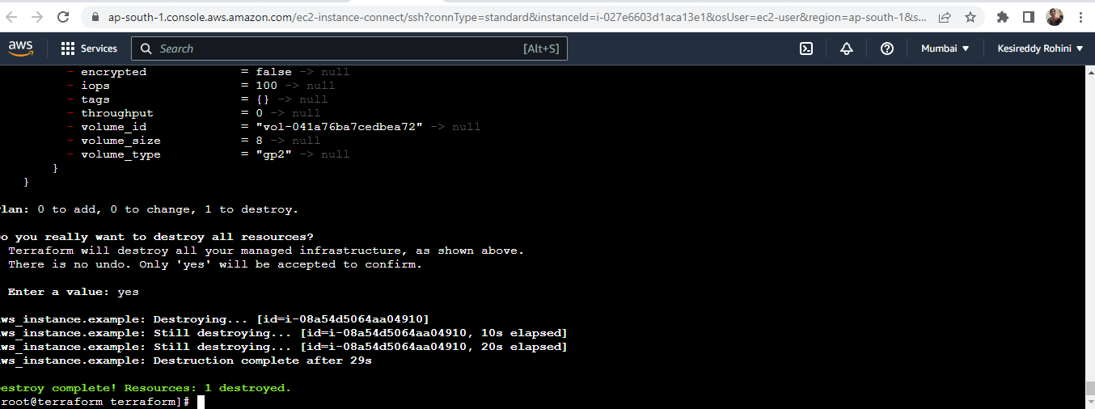

**Instance is terminated**



**Creating S3 bucket using terraform**

**Creating 3 files named variables.tf, main.tf, output.tf**

**Output.tf:**

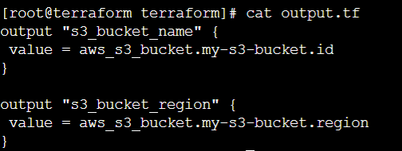

**Variables.tf**

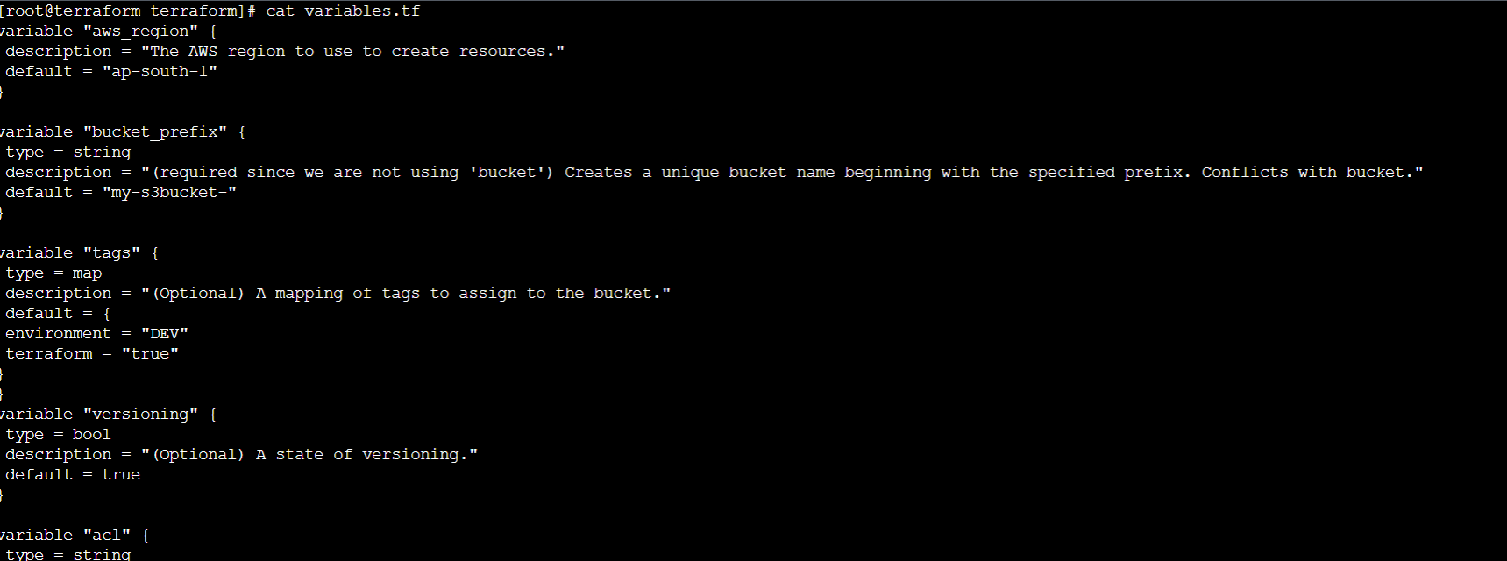

**Main.tf**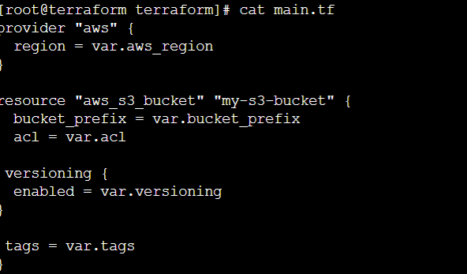

**Terraform Init:**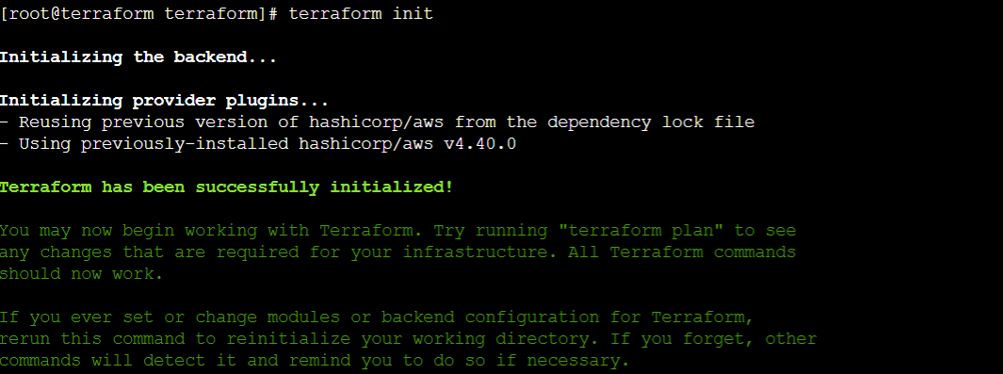

**Terraform validate:**

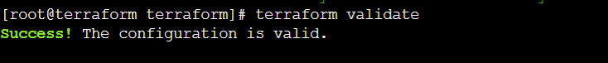

**Terraform apply:**

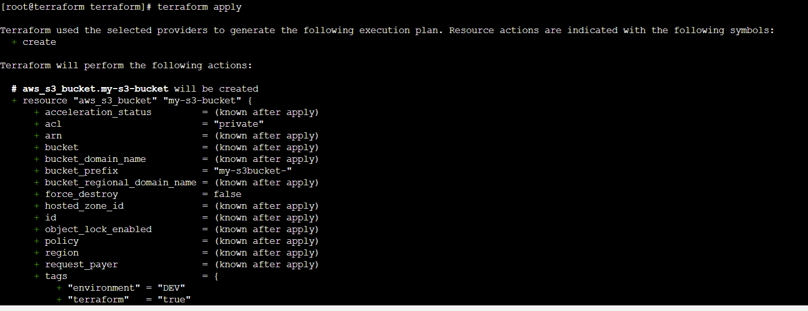

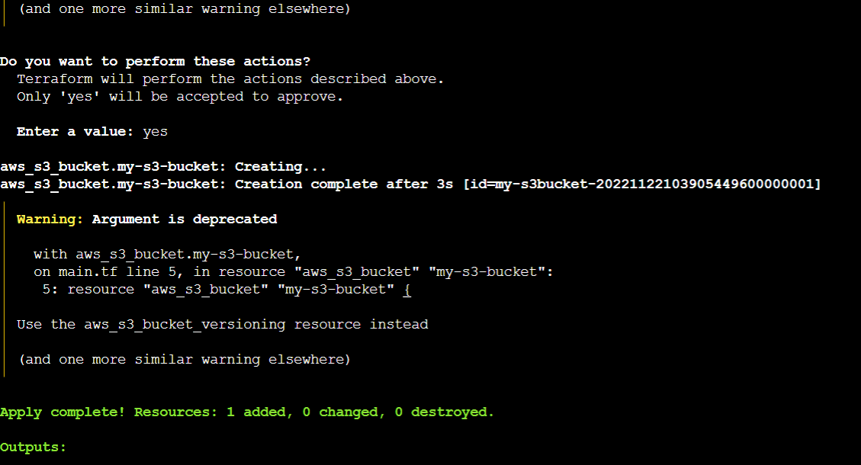

**Bucket created:**

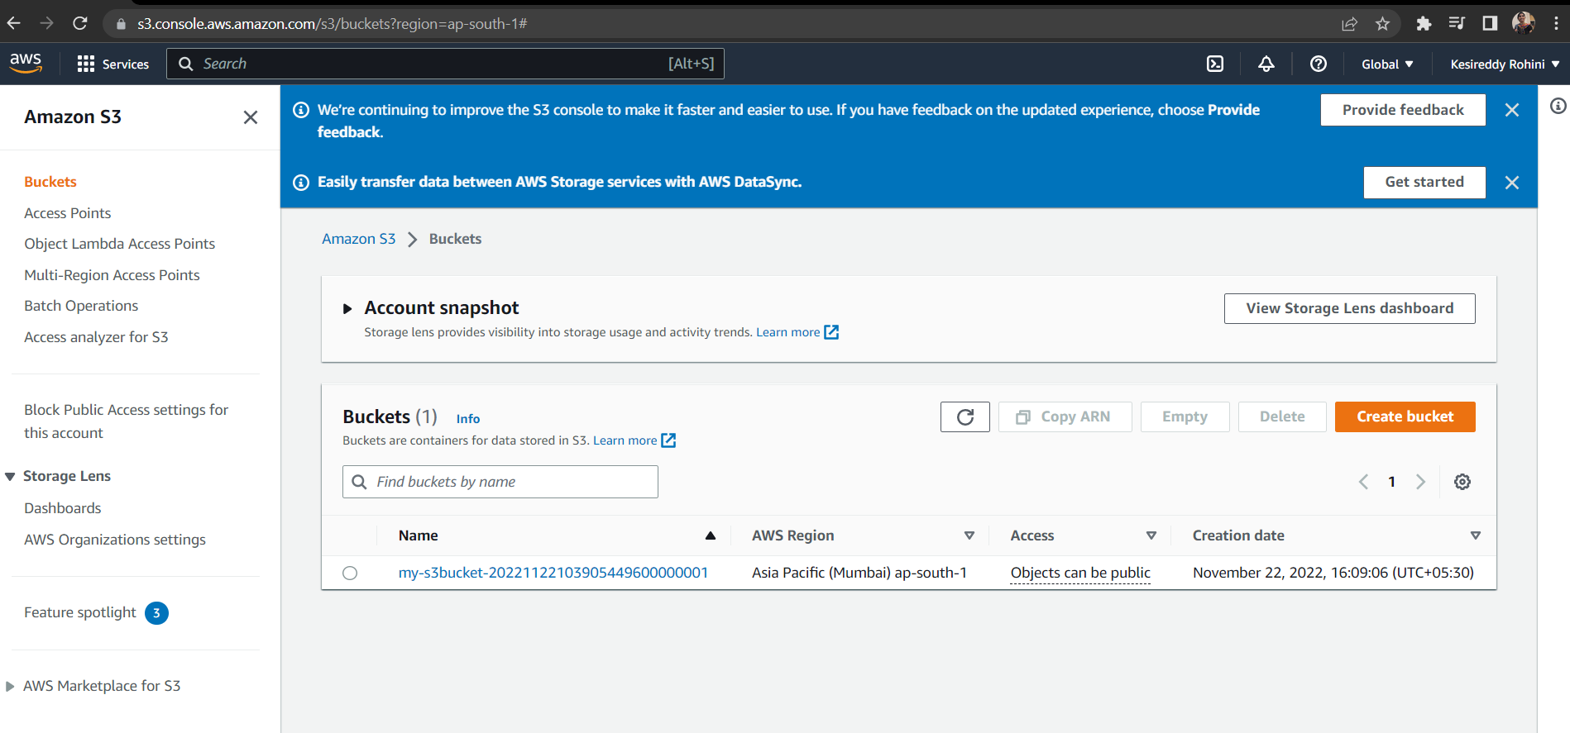

**Deleting the bucket which was created**

**Terraform destroy:**

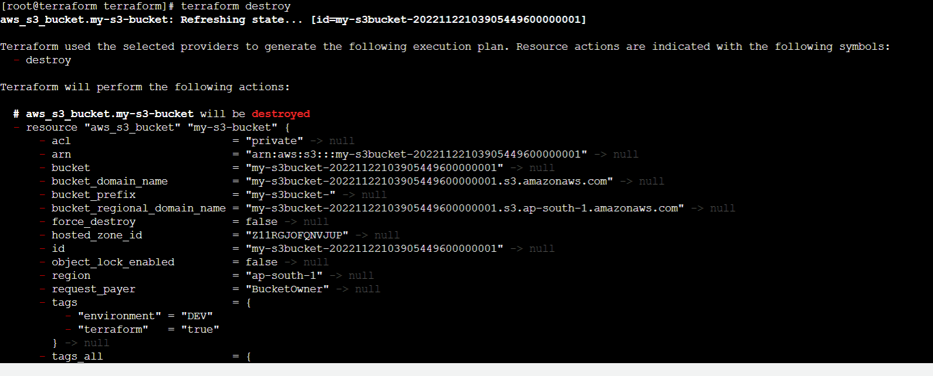

**S3 bucket is deleted**

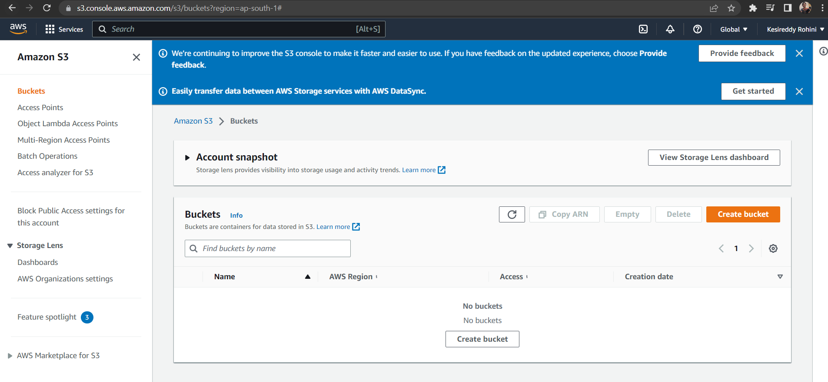

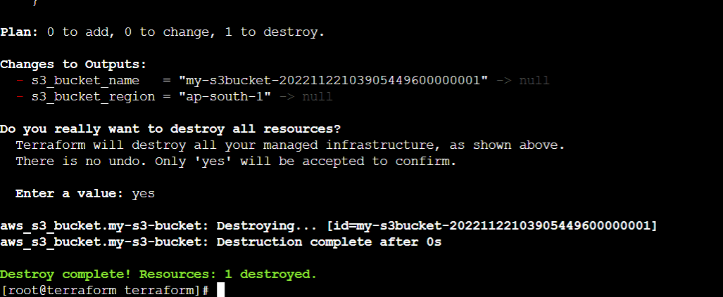

**Creating IAM users using terraform**

**Created four files with names main.tf, output.tf, policies.tf, variables.tf**

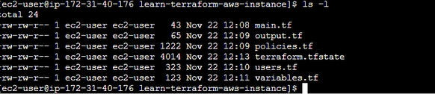

**Main.tf**



**Output.tf**



**Policies.tf**

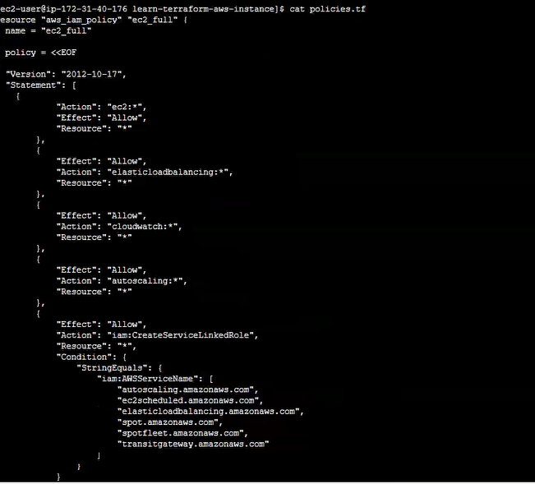

**Variable.tf**

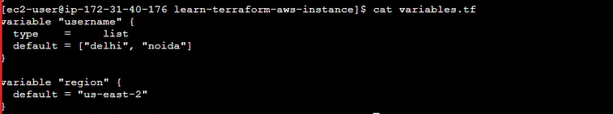

**Users.tf**

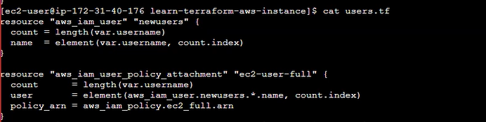

**Terraform init**

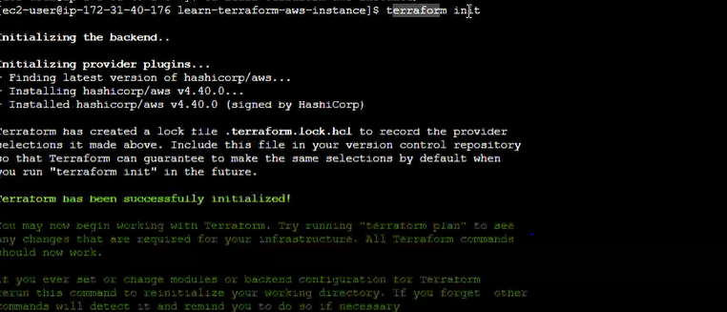

**Terraform valid**



**Terraform apply**

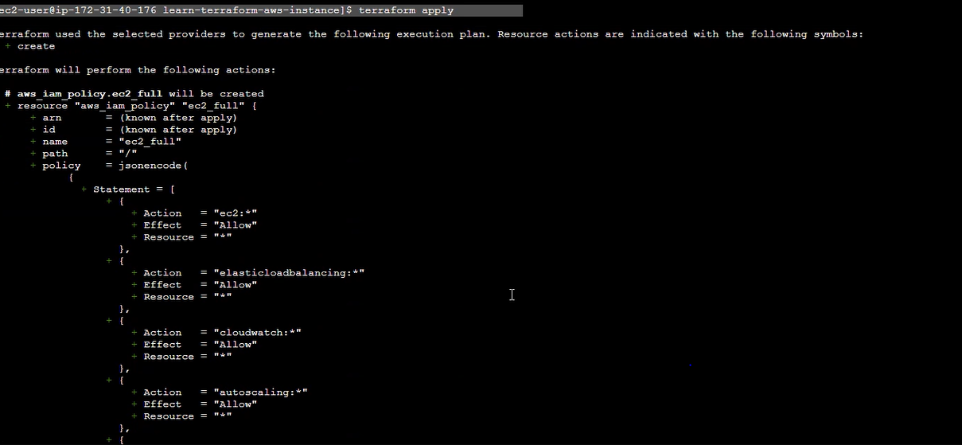

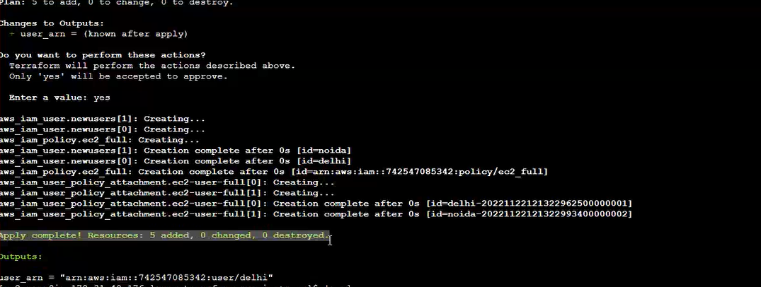

**Iam users are created**

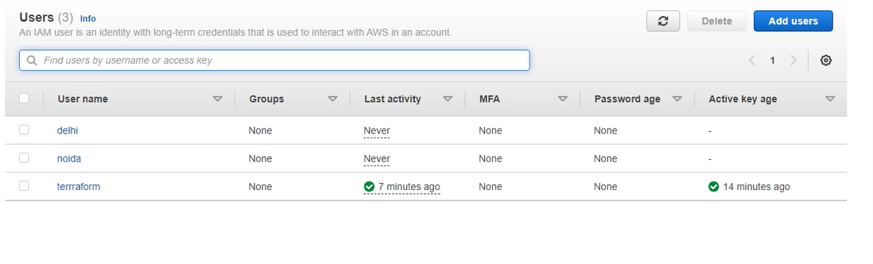

**Terraform destroy**

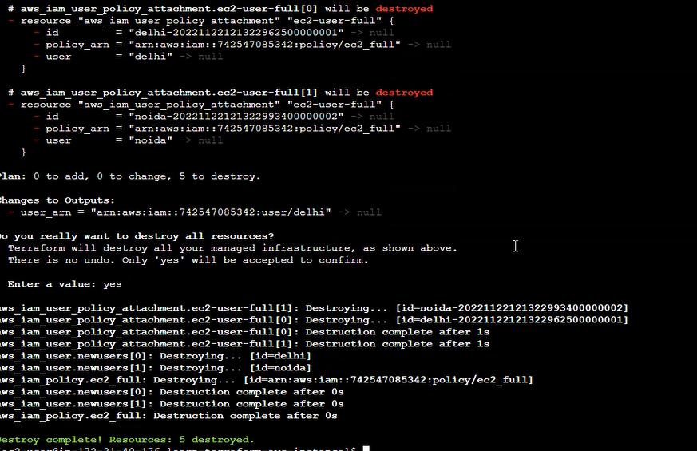

**Users are destroyed**

